|  |  |  |  |  |  |  |
| --- | --- | --- | --- | --- | --- | --- |
| **Count of Cause of Death/Burial** | **Column Labels** | |  |  |  |  |
| **Row Labels** | **Diareah** | **Diarherea** | **Diarrhaea** | **Diarrhea** | **Diarrhoea** | **Grand Total** |
| 1846 |  | 18 |  |  |  | 18 |
| 1847 |  | 28 |  |  |  | 28 |
| 1848 |  | 24 |  |  |  | 24 |
| 1849 |  | 1 |  |  |  | 1 |
| 1853 | 4 |  |  |  |  | 4 |
| 1854 | 3 |  |  |  |  | 3 |
| 1855 | 7 |  |  |  |  | 7 |
| 1857 | 1 |  |  |  |  | 1 |
| 1858 | 1 |  |  |  |  | 1 |
| 1859 | 1 |  |  |  |  | 1 |
| 1860 | 2 |  |  |  |  | 2 |
| 1861 | 3 |  |  |  |  | 3 |
| 1862 |  |  | 1 | 2 | 3 | 6 |
| 1863 |  |  | 3 | 3 | 11 | 17 |
| 1864 |  |  | 24 | 2 | 9 | 35 |
| 1865 |  |  | 27 | 1 | 2 | 30 |
| 1866 |  |  | 24 |  | 3 | 27 |
| 1867 |  |  | 3 |  |  | 3 |
| 1880 |  |  |  | 2 |  | 2 |
| **Grand Total** | **22** | **71** | **82** | **10** | **28** | **213** |

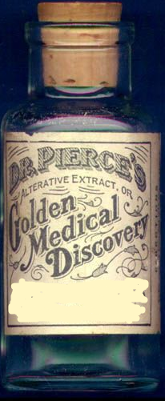

Present

1862-1867

1853-1861

1846-1849

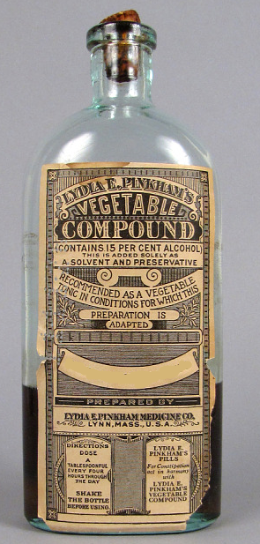

**Great for Diarherea!**

History gives new hope to those who have struggled all their lives with spelling! Can’t spell tough words like “diarrhea,” “abscess,” or “jaundice?” Neither can history! Come to the Historic Nashville City Cemetery, and we’ll show you why your best bet might just be to wait it out 5-10 years.

Diarrhea!

**Diarrhaea**

Diareah Tablets!